Emergency Response Mapping Sphere



Critical Design Review

Team ERMS
Brandon Le
Kiet Nguyen
Hai Yen Nguyen
Josh Wu
Antony Quach

Department of Computer Science
Texas A&M University

March 25, 2026
Table of Contents (Be sure to regenerate before submitting).

1 Introduction (1 page; 5 points) 2
2 Proposed design (5-10 pages; 60 points) 4
2.1 Updates to the proposal design (if applicable) 4
2.2 System description (1-2 pages; 30 points) 5
2.3 Complete module-wise specifications (4-6 pages; 30 points) 5
2.3.1 Ball Hardware 5
2.3.2 Ball Electronic Connections 6
2.3.3 Raspberry Pi Selection 7
2.3.4 Camera Cutting Algorithm 7
2.3.5 Camera Multiplexing 7
2.3.7 Connectivity 8
2.3.8 Ball to Server Dataflow 8
2.3.9 Live Object Detection 8
2.3.10 Gaussian Splatting 8
2.3.11 Server to Operator Dataflow 9
3 Project management (3-5 pages; 30 points) 10
3.1 Updated implementation schedule (1 page; 10 points) 10
3.2 Updated validation and testing procedures (1 page; 10 points) 11
3.3 Updated division of labor and responsibilities (2 pages; 10 points) 13
4 Preliminary results (1-2 pages; 5 points) 13
4.1 Smoke Environment Camera Validation 13
5 References 16

Introduction (1 page; 5 points)
The Critical Design Review (CDR) defines a transition between the design stage of your project and the implementation/integration stages. In a typical project, all decisions have been made at this point concerning what will be built and how it will be tested. The objective of the CDR is to present a complete design of the system, an implementation plan and validation/testing procedures.
In this introductory section, you will provide a brief overview of the project. This section helps the reader put into context the design and implementation that you will propose next. The overview should include:
- general scope and problem background,
Emergency response operations require rapid and accurate situational awareness, especially in hazardous environments where traditional methods are impractical or dangerous. First responders are routinely entering unfamiliar space such as structurally compromised buildings, active threat scenarios, and chemical spill sites, where visibility is often limited and conditions are very unpredictable. These challenges significantly increase the risk of injury, delay rescue efforts, and can lead to poor tactical decision-making in critical moments. Although current technologies such as drones, body-worn cameras, and robotic systems are used to support these operations, they frequently provide incomplete spatial information, suffer communication delays, or fail to function in confined indoor environments. Drones cannot navigate tight corridors, wheeled robots struggle with debris and rough surfaces, and stationary cameras offer limited field of vision. As a result, existing technologies do not sufficiently reduce operational risk or provide the level of real-time situational awareness necessary to ensure responder safety and mission success.

- needs statement,
First responders routinely have to enter dangerous structures as part of their jobs. Hazards such as structural integrity, fire, or live threats slows them down during time sensitive missions and risks their lives. From 2018 to 2020, 87% of firefighter injuries occurred during structure fires, highlighting the significant dangers associated with indoor emergency response. Additionally, active shooter incidents last an average of only 12 minutes, leaving little time for responders to assess and secure a scene. Existing solutions are upwards of thousands of dollars and tend to require a skilled operator. These statistics demonstrate the urgent need for a device that first responders can deploy quickly to enhance safety and situational awareness in hazardous environments.
The previously designed Throwable Environment Scanner addresses this need but is lacking in some areas. Currently, its 3D mapping capabilities are not clear enough to allow users to be confident that all threats have been identified, demonstrating a need for improvements in threat identification. Furthermore, users may find it difficult to use the map, showing that a more intuitive user interface is needed.

- goals and objectives, and
The goal of this project is to enhance the Throwable Environment Scanner so that it can deliver high-quality 3D mapping directly to a first responder’s device while improving existing system efficiency.
The main objective of the system is to utilize onboard cameras to stream live video and reconstruct a 3D representation of the surrounding environment, improving situational awareness and enabling more effective threat detection. At the same time, the device must maintain its portability and durability to remain practical for field deployment. It will be limited to a maximum weight of 3 pounds and a maximum diameter of 7 inches, while also being capable of withstanding drops and collisions in hazardous conditions. The device must support 30 minutes of continuous operation at a minimum to ensure reliability during active incidents and be able to start up within 30 seconds to reduce delays. Additionally, the project must remain within cost constraints, with a maximum budget of $250 allocated for design iterations. The system must also provide threat identification in the environment to reduce mental load on users.

- design constraints
One of the primary challenges of this project is ensuring that the first responder’s get an accurate representation of the environment with low latency. The 3D model generation and threat identification must take less time than traditional methods of ensuring safety in dangerous structures. Processing and reconstructing high-resolution spatial data requires significant computational resources, which may introduce latency and limit real-time usability. Additionally, the device must be engineered to withstand strong and repeated impacts, as it is designed to be thrown into hazardous environments. This requires a durable outer structure that protects internal components without exceeding weight and size constraints. Finally, the hardware must support complex transmission logic capable of delivering high-resolution images and mapping data quickly and reliably. Efficient data compression, wireless communication stability, and low-latency streaming will help maintain performance under emergency response conditions. Given that the durability and portability objectives of the system have already been tested, all objectives can be completed fully if threat detection and environment reconstruction algorithms are sufficiently fast and camera data quality is sufficiently accurate.

- validation and testing procedures

- Camera Quality: The images taken by the camera should be checked to ensure that they clearly picture the environment and objects in the images are easy to identify. The photos captured by the camera will be compared to the environment to ensure accuracy.
- Wireless transmission: Because the ball is intended to be used remotely, the ball must be capable of transmitting wirelessly from a distance through walls and objects. To test this, we plan to operate the ball through 10m of obstacles and evaluate for latency and data loss.
- User interface: Because our tool is meant to have little operator training required, the user interface must be intuitive and easy to use. To test this, we will use third parties as operators. While the test operators use the system, we will observe them and ask about their experience.
- Mapping algorithms: If the 3D environments are not accurate to the real environment, operators may make decisions based on incorrect information. We will compare the generated environments against measurements of the real one to ensure accuracy.
- Live object identification: Hidden live objects may not be easy for operators to identify. To ensure the system can identify live objects, we will operate it in an environment with humans and or animals, in varying degrees of hiddenness, and compare the generated flagged objects to the real ones to ensure that the system does accurately flag live or moving objects.
- Lifespan test: The device must operate for long enough that it can be used to explore multiple environments and to monitor changes in environments. The ball will be fully charged and operated until it runs out of battery to determine its lifespan.

Proposed design (5-10 pages; 60 points)

Updates to the proposal design (if applicable)
Your initial design may have changed from what was initial conceived in the project proposal. For this reason, you should provide an update on:
- additional findings from the literature or technical documentation, e.g., a new product may have just been released, or someone pointed you in the direction of a research project you didn’t know about at the time the proposal was written,
- new alternatives that you have considered, e.g., as a result of the above findings or problems you may have encountered in your original design, and
- changes in the budget, along with a justification for these changes.

System description (1-2 pages; 30 points)
The system description will consist of a high-level block diagram, and a functional description of the different parts and interfaces.

The Emergency Response Mapping Sphere is designed to capture and reconstruct a 3D representation of an environment in real time using a distributed architecture consisting of three main components: the ball subsystem, the server subsystem, and the operator interface. The ball subsystem contains a Raspberry Pi 4B connected to three wide-angle cameras and an inertial measurement unit (IMU). These components work together to capture timestamped images from multiple viewpoints while determining the ball’s orientation to selectively disable cameras that are facing downward. The captured images are processed locally only to the extent necessary for camera selection, and are then transmitted wirelessly to the server.

Communication between all system components is established over Wi-Fi using a secure Tailscale network, allowing seamless connectivity between the ball, server, and operator regardless of physical location. The ball sends image data to the server through HTTP POST requests to a FastAPI endpoint. Each image file includes embedded metadata in its filename, such as timestamp, ball ID, and camera ID, enabling the server to synchronize data from multiple sources. This design ensures that the system remains scalable and can support multiple devices operating simultaneously.

The server subsystem is responsible for the computationally intensive tasks of processing incoming image data, performing object detection, and reconstructing the environment. Incoming images are first analyzed using a YOLO-based object detection model to identify relevant objects such as people or obstacles. In parallel, a SLAM-based method is used to estimate camera poses from sequential images. These images and pose estimates are then used to generate a 3D representation of the environment using Gaussian splatting, which allows for efficient real-time rendering of the scene. Detected objects are projected into the reconstructed 3D space, enabling the system to produce a semantic map that includes both structural and object-level information.

Rather than transmitting the full reconstructed model to the operator, the system leverages the server’s GPU to render the environment locally and stream the visualization. The operator interface connects to the server via WebRTC, allowing the user to remotely view and interact with the reconstructed scene in real time. This approach reduces bandwidth requirements and ensures smooth performance by offloading heavy rendering tasks to the server. Overall, the system integrates embedded hardware, wireless communication, and advanced computer vision techniques to provide a responsive and scalable solution for real-time environmental mapping.

Complete module-wise specifications (4-6 pages; 30 points)

Ball Hardware
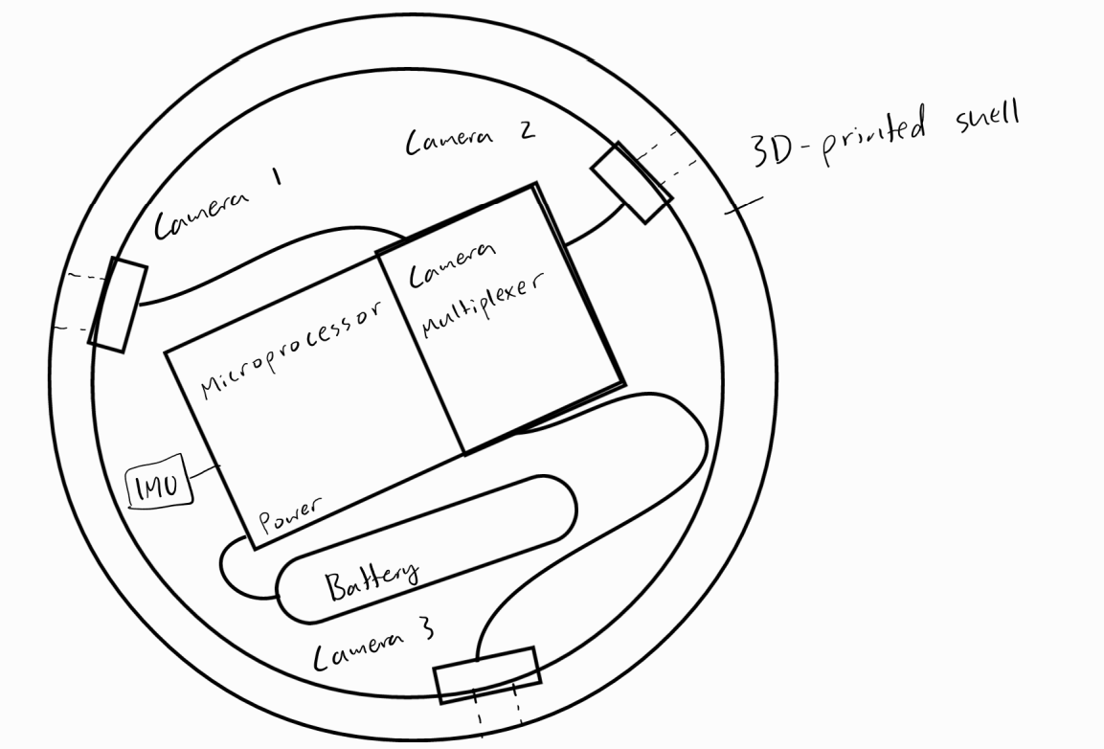
Figure 1: Circuit diagram of ball subsystem.
The ball’s basic electronic components and connections can be seen in Figure 1. At a high level, three cameras are placed equidistant along the equator of the ball. These are multiplexed to the ball via a dedicated multi-cam adapter board. The Pi microprocessor communicates with the cameras via the multiplexer. The Pi is powered by a battery. In addition, an IMU is added to improve throughput for the multiplexed system through a camera cutting algorithm.

Ball Electronic Connections
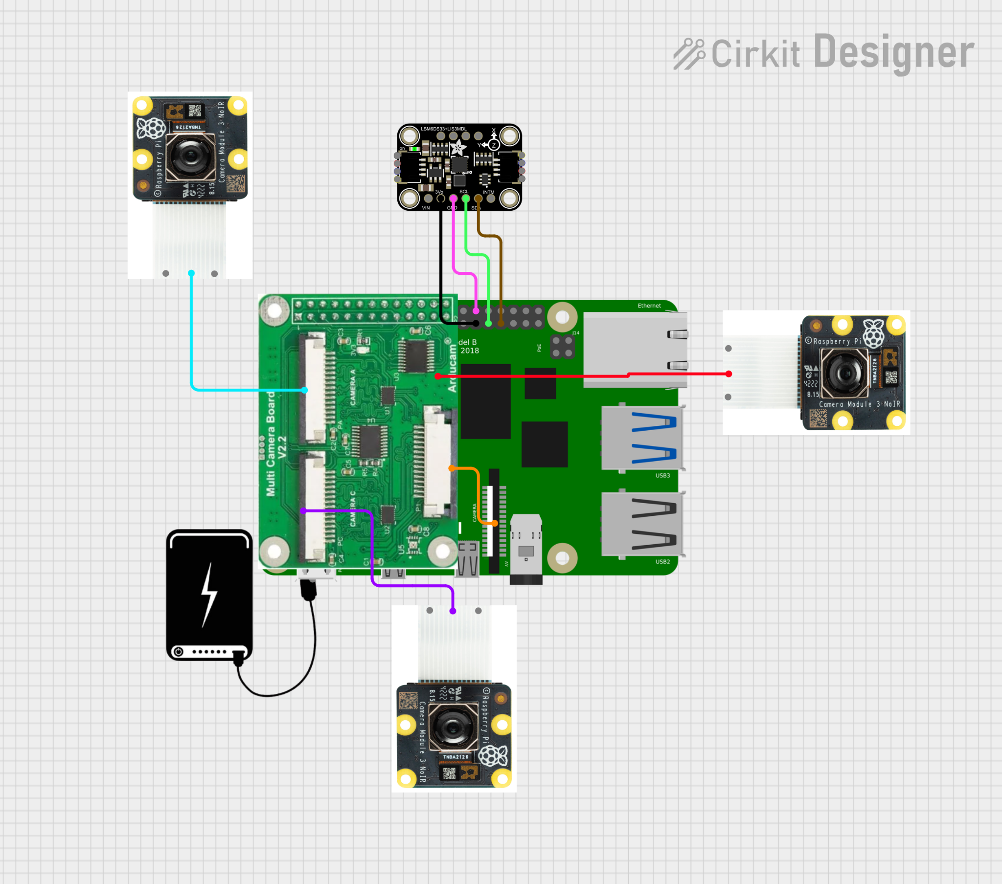
Figure 2: Pinout diagram of the electronics. Note, the green section represents two components.
A pinout diagram is shown in Figure 2. The multiplexer and Pi board are pictured center center. It may be difficult to tell them apart because the multiplexer is a Hardware Attached on Top (HAT) device, meaning it connects to the Pi board by sitting on top of it. The left half is the multiplexer, attached directly onto the Pi’s GPIO pins 1-26 via a 2x13 GPIO header. The Pi board is underneath the multiplexer and extends to the right. In addition, the multiplexer’s output is connected to the Pi’s camera port using a short 15x1.0mm FPC ribbon cable. The three cameras are pictured top left, center right, and bottom center and connect to the multiplexer via 15x1.0mm FPC ribbon cables as well. The rightmost camera is connected to one of two ports not visible on the underside of the multiplexer. The IMU is the black board pictured top center. Because the HAT multiplexer covers many of the pins that the IMU would usually take, we use “bit banging” to repurpose the GPIO pins to serve a different purpose from what they usually do. Using this approach, we can connect the IMU to any kind of GPIO pins. From left to right, the IMU wires in the diagram go to GPIO physical pin 29 (GPIO 5), pin 30 (GND), pin 31 (GPIO 6), and pin 33 (GPIO 13). The power bank is able to connect to the Pi board’s USB-C power port.

Raspberry Pi Selection
For our Raspberry Pi, we’ve decided on a Raspberry Pi 4B due to having sufficient processing capabilities but with lower power consumption and costs. An alternative design choice was a Raspberry Pi 5 which processes better, but requires higher power consumption which leads to requiring a larger battery. That in turn becomes too expensive for our budget.

Camera Cutting Algorithm
The camera cutting algorithm will be performed by the ball with no communication to the server or operator. The idea behind it is that the ball should know the orientation of the cameras related to the floor and avoid using a camera facing downwards. The ball will be initially still. While still, the accelerometer part of the IMU can determine the ball’s orientation by identifying the direction of gravity because it will be the only force acting on it. After the direction of gravity is found, the ball knows which way is down assuming the floor is not very steeply angled. The Pi will constantly ask the gyroscope portion of the IMU for angular velocity data. It will perform numerical integration on this over time to determine orientation. Then, using vector math, we can take the dot product to find the angle between them. If this angle is within a certain threshold, we can assume that the camera will capture mostly the floor, which is not useful. Compared to using all three cameras at all times, cutting a camera improves the throughput of our useful data by up to 50% since all images will be useful instead of only two thirds. This will also reduce current by up to 33% for the same reason.

Camera Multiplexing
The camera multiplexing is implemented as a software process using the Arducam Multi Camera Adapter. The adapter creates virtual I2C buses for each camera to keep them separate and avoid needing to create unique addresses. Before using a port on the multiplexer, it must be enabled by writing to it over I2C. These separate channels allow the cameras to be recognized as separate devices by the Linux media controller, which libcamera, a popular camera library, uses. The multiplexer dedicates three GPIO pins to be used as control lines to select a camera port. Once initialization is complete, it takes milliseconds to switch between the pins using the GPIO control lines. Using PiCamera2, a Raspberry Pi camera controller built on libcamera, we can instruct the selected camera to take a picture and store it as a jpeg.

    - Current and power consumption

We calculated the power consumption between 3 different options for camera modules: CSI (ribbon cables), usb cameras, and the regular cameras used by the previous group (where each camera was connected to a Raspberry Pi 2).

Metric | 3x CSI (Mux) | 3x USB | 3x RPi 2 Cluster
Total Current | ~1.26 A | ~1.5 A | ~1.44 A
Power | 6.426 W | 8.16 W | 7.344 W

Based on the calculations, the CSI Mux requires both the lowest power and current consumption, making it the most efficient option for a battery-powered system while still meeting system requirements.

CSI vs USB Cameras

Category | CSI Camera (Camera Module 3) | USB Camera
Connection Interface | Dedicated CSI (MIPI) port | USB (shared bus)
Bandwidth Path | Direct to GPU/ISP | Shared USB bandwidth
Typical Max Resolution/FPS | 1080p @ 50 FPS, 720p @ 100 FPS | Typically 1080p @ 30 FPS (higher requires compression)
Data Transfer Efficiency | High (optimized pipeline) | Lower (USB overhead + encoding)
Latency | Low | Higher
CPU Usage | Low (hardware ISP acceleration) | Higher (MJPEG decode / processing)
Multi-Camera Support | Requires multiplexer (1 active) | Multiple simultaneous cameras possible
Bandwidth Limitation | Not shared with USB | ~480 Mbps (USB 2.0 bottleneck)
Processing Speed | Faster frame delivery and processing | Slower due to bus + format overhead
System Load | More efficient | More CPU + bus load

CSI cameras are selected over USB cameras because they provide significantly better processing performance on the Raspberry Pi 4B. CSI cameras connect directly to the Raspberry Pi’s dedicated camera interface, allowing data to be transferred through an optimized imaging pipeline with minimal latency and lower CPU overhead. In contrast, USB cameras rely on a shared USB bus with limited bandwidth and often require additional processing for compressed video formats such as MJPEG, which increases CPU usage and reduces overall system efficiency. As a result, CSI cameras enable higher frame rates, faster image processing, and more reliable performance, making them the better choice for real-time applications such as the throwable scanner system.
Multi-Camera Support | Requires multiplexer (1 active) | Multiple simultaneous cameras possible
Bandwidth Limitation | Not shared with USB | ~480 Mbps (USB 2.0 bottleneck)
Processing Speed | Faster frame delivery and processing | Slower due to bus + format overhead
System Load | More efficient | More CPU + bus load

Connectivity
All modules of the system, including the ball, server, and operator’s viewer, are connected via Wi-Fi. Each component joins a tailscale network, allowing them to communicate with each other.

Ball to Server Dataflow
The only data needed to be sent to the server is the timestamped image with some identification. All of this information is contained in the file and its filename. The filename includes the timestamp, ID of the ball, and ID of the camera in the ball. This allows a server to handle information sent from any number of balls and synchronize the incoming data. The file is sent using a POST request which hits the server’s FAST API endpoint.

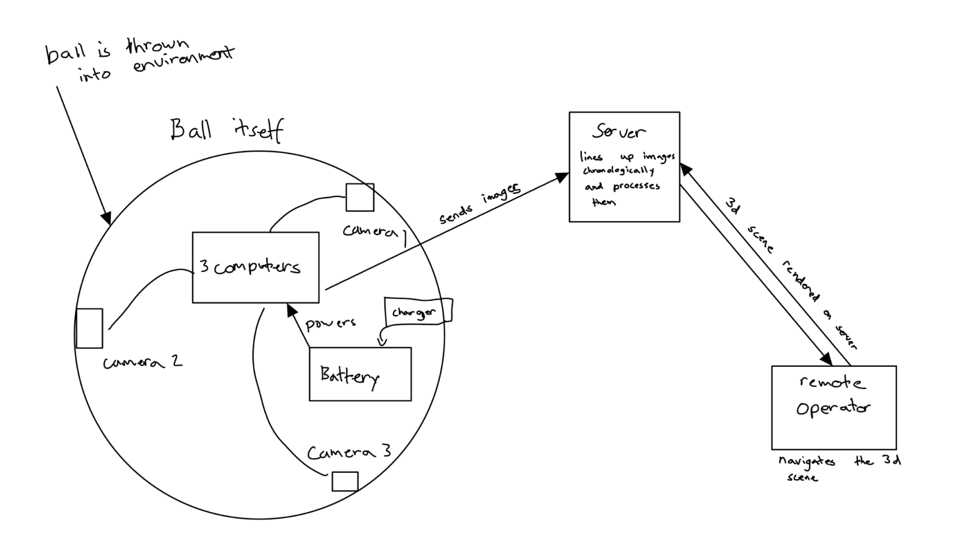
Figure 3: diagram of how data is transmitted from ball to server to operator.

Live Object Detection
Live object detection is performed using YOLO. YOLO is lightweight and very fast compared to other methods of object detection, which is especially useful because the modeling algorithm is very computation heavy. The only drawback is that it is not as accurate as other methods. However, because the operator is able to navigate the scene themselves, having an exact. Also, because it only looks at one image and does not compare different images, YOLO cannot explicitly know if an object has moved. Instead, it can identify objects in each picture that are typically able to move, such as humans or animals, and classify them. From the objects YOLO detects, we can estimate the position of the object, which is later refined and rendered during gaussian splatting.

Gaussian Splatting
Gaussian splatting will be used as the primary method for reconstructing a 3D representation of the environment from multi-view image data collected by the throwable device. Each Raspberry Pi camera captures timestamped images, which are sent to the server via a FAST API POST request, with filenames encoding the timestamp, ball ID, and camera ID to enable synchronization across multiple devices. Since the cameras do not provide depth information, camera poses are estimated using a SLAM-based approach, specifically MAST3R SLAM, which processes sequential images to determine camera position and generate a sparse geometric understanding of the scene. These images and estimated poses are then used to train a 3D Gaussian Splatting model, which represents the environment as a collection of 3D Gaussians that can be rendered in real time. In parallel, live object detection is performed on incoming images using YOLO, which provides fast, per-frame identification of objects such as people or obstacles. Although YOLO operates on individual images and cannot inherently track motion across frames, it enables rapid classification of potentially dynamic objects. These detections are then projected into the reconstructed 3D Gaussian scene using the estimated camera poses, allowing approximate object positions to be visualized within the environment. During rendering, detected objects are injected into the scene, where their positions can be refined as more data is accumulated. This combined pipeline enables the system to generate a semantic 3D map that includes both the static structure of the environment and the estimated locations of relevant objects, improving situational awareness for the operator.

Server to Operator Dataflow
The server’s rendered model can be viewed on a platform on the server. Instead of constantly sending updated models to the operator, we can take advantage of having a GPU on the server and efficiently view it there. The viewer is streamed to the operator over WebRTC, who can interact with the viewer from their remote location. Therefore, the only data sent is over WebRTC.

    - GPU Provider
To support the computational demands of our 3D reconstruction pipeline—particularly Gaussian splatting and future extensions such as 4D Gaussian Transformers—we initially defined a set of target specifications for a cloud-based GPU provider. These requirements were chosen to ensure sufficient performance for real-time or near-real-time processing of high-resolution image data transmitted from the ball.
For GPU provider, we ideally wanted one with the following specs:
- Pricing/hr: <$2
- GPU name: RTX 3090
- VRAM: 16-32 GB
- memory bandwidth: 936 GB/s
- CPU spec: AMD 7900X (12 core, 24 thread, equivalent ~24 vCPUs)
- Proximity: located in central US
- Storage: 100 GB
Due to low availability and costs, we pivoted to Brandon’s laptop as the GPU provider because it has a CPU AMD Ryzen 9 270, GPU: RTX 5070 with VRAM 8 GB, which should be powerful enough to sustain the project.

Table 1: A parts list of materials purchased for the design.
 | Amount | Cost per Unit ($) | Total Amount ($)
Raspberry Pi 4B, 2GB RAM | 1 | 59.50 | 59.50
Raspberry Pi Camera Module 3 Wide Noir | 3 | 38.50 | 115.50
Adafruit ST ISM330DHCX 6-DOF IMU | 1 | 19.95 | 19.95
Power Bank | 1 | 9 | 9
Multi Camera Adapter | 1 | 50 | 50
3D-printer filament (ABS, 1 kg) | 1 | 11 | 11
Misc. fasteners, heat-shrink, etc. | - | ~5 | ~5
Total Cost |  |  | 269.95

The cost of the project is estimated to go ~$20 over the $250 budget. This is largely due to finding out that the initially desired gyroscope in the IMU is no longer an option because it has been discontinued. In addition, we found that we need a different model regardless because the ball rotates too fast for a cheaper gyroscope to work. We have also chosen to use 2GB of RAM in the Pi instead of only 1GB as in the proposal because of the added computation needed to perform the camera cutting algorithm.

Project management (3-5 pages; 30 points)
Briefly review the roles and responsibilities of each team member (e.g., team leader, systems design, software design, hardware design, finance and purchases, testing, technical reporting, etc.) Provide any updates on the mechanisms that you are using to manage the project as a team, such as brainstorming sessions, keeping track of progress on every task, etc. Is your management approach working? If not, what types of improvement are you putting in action?

Updated implementation schedule (1 page; 10 points)
Provide a feasible schedule for implementing your design. Break down the implementation into clearly identified steps, analyze dependencies among them, identify critical paths, and design a feasible schedule for accomplishing these tasks.
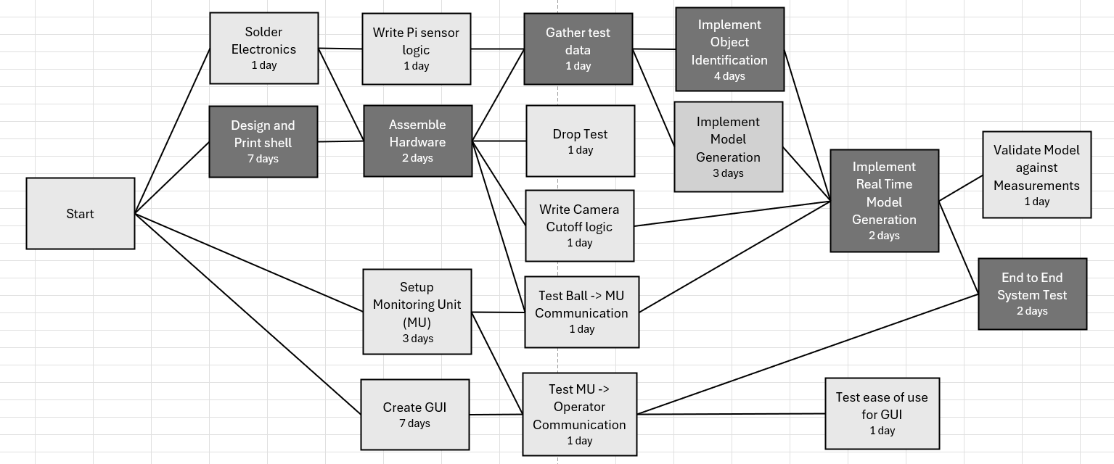
We seek to complete multiple tasks simultaneously, as most are not dependent on each other to complete. This includes tasks like shell design and camera algorithm implementation. However, we also want to prioritize software implementation, as there are tasks that require the basic software implementation to be completed before starting. This includes the Gaussian Splatting and Object Detection ideally only being started once we have implemented the camera algorithms so we are familiar with how data is formatted. Software tasks only depend on hardware tasks that implement new components like cameras or the IMU. The only remaining hardware task of this kind is connecting the IMU. Other hardware tasks like shell design can be done separately from software development, only being needed for tests like the drop test. The critical path for implementation is about 18 days, dependent on establishing the hardware soon enough to properly start implementing more complex algorithms like object detection and real time model generation.

Updated validation and testing procedures (1 page; 10 points)
Update the procedures that you will use to test that your system does what it was designed to do. How are you going to measure the extent to which your system solves the need? What kind of demonstration will you provide as proof of a working system? We’re not talking here about component testing, which should be part of the implementation schedule. These validation and testing procedures are at the system level (a working prototype).

The following table summarizes the system-level validation and testing procedures for the working prototype. Each requirement is paired with a verification method and pass criteria to demonstrate that the system meets its design goals.

Requirement Type | Requirement | Verification Method | Pass Criteria
Performance | 3D Model generated ≤ 30s | Timestamp logging | ≤ 30 seconds
Performance | Stream ≥ 5 fps at 720p resolution | Measure frame rate over 60-second streaming sessions using software like OpenCV | Average ≥ 5 fps sustained
Functionality | Components fit & remain functional while in motion | Physical assembly check and rolling tests. | All components fit and all cameras operational during rolling test
Functionality | Detect orientation and downward-facing camera | Orientation test (6 positions) and compare sensor output to ground truth | ≤ 95% of trials correct
Functionality | System setup for throwing ball should take ≤ 20s | Time operator from power-on to throw-ready | ≤ 25s on average
Energy | Reduce power by disabling downward camera | Measure current draw with and without IMU and camera disabling | ≥ 15% reduction
Environmental | Ball diameter ≤ 7 inches for portability | Measure final assembled ball diameter | ≥ 7 inches
Economic | Prototyping cost < $250 | Inspection of Bill of Materials | Total cost is less than $250
Legal | Use FCC compliant Wi-Fi modules | Inspection of module documentation | Datasheet shows FCC compliance
Safety | Shell should be made of fire resistant material | Inspection of material datasheet | Datasheet shows material withstands heat up to 100 C
Maintainability | Internal electronics accessible by standard tools | Disassemble and reassemble using standard screwdrivers | Test is performed with no structural damage
Usability | GUI is usable without requiring coding | User test demonstration | A user with no programming background completes defined tasks successfully
Reliability | Survive 2m drop without damage | Drop test from 2 meters (3 trials) onto concrete | No structural damage, system still functional

Updated division of labor and responsibilities (2 pages; 10 points)
Provide a detailed list of deliverables (and due dates) for each team member.

Team(s) | Task | Team Member | Due Date
Software | Calculate all power and current consumption to determine potential smaller batteries/cheaper alternatives. | Brandon Le | 3/25/26
Software/Hardware | Implement base Camera switching script to determine latency in camera switching and still capture images. | Antony Quach  Hai Yen Nguyen | 3/25/26
Software | Write gyroscope code to include an IMU sensor for determining which camera should be turned off to conserve power and processing power. | Josh Wu | 3/27/26
Hardware | Bit-banging to implement IMU via hardware changing + soldering | Kiet Nguyen | 3/30/26
Hardware | 3D-print new shell to account for hardware changes including single Pi 4, multi-cam adapter, and IMU sensor. | Kiet Nguyen | 3/30/26
Hardware | Look into the Gaussian Splat algorithm and potentially test with photos to gauge difficulty and implementation with capture streams. | Antony Quach | N/A
Software/Hardware | Conduct camera switching algorithm iterations via trials to find optimized/sufficient speed and environmental coverage. | Antony Quach  Hai Yen Nguyen | N/A

Preliminary results (1-2 pages; 5 points)
Provide any test results and demo of completed parts of the system at the time of the CDR.

4.1 Smoke Environment Camera Validation
To compare and validate our design choices between the NoIR Wide Camera and the Regular Wide Camera, an experiment was conducted to evaluate the performance of both cameras in a simulated smoky environment representative of the conditions in which the device will be deployed.
A controlled smoke environment was created using incense sticks to incrementally increase smoke density.
Smoke Test Procedure per Smoke Level
1. Set the smoke level using incense sticks
2. Wait 60 seconds for smoke to stabilize
3. Capture images with first Camera (Regular)
4. Switch cameras with multiplexer
5. Wait ~5 sec for camera to stabilize
6. Capture images with second camera (NoIR)

Images were captured under:
- Normal lighting conditions
- Low-light (darkness) conditions

Evaluation Metrics
Contrast CDI (Contrast Degradation Index)
Contrast CDI measures how well the camera can distinguish between the bright white stripes and dark black stripes on the target pattern, so the higher the number, the better.
It ranges from 0 to 1:
1.0 = perfect: the camera sees pure white and pure black, no smoke interference
0.0 = completely degraded: everything looks the same gray, the stripes are invisible

Sharpness
Quantifies image clarity by measuring the strength of intensity changes in the image. Higher values indicate stronger edge definition and better preservation of detail.

Edges
Represents the number of detected edge features in the image. Higher edge values indicate better preservation of structural detail, which is critical for object detection and 3D mapping.

Experimental Data
Lighting | Smoke Density (sticks) | Camera | Contrast (CDI) | Sharpness | Edges
dark | 0 | noir | 0.5556 | 2.46 | 0
dark | 0 | regular | 0.6667 | 2.36 | 0
dark | 1 | noir | 0.7429 | 2.64 | 461
dark | 1 | regular | 0.7674 | 2.41 | 0
dark | 3 | noir | 0.5135 | 2.6 | 899
dark | 3 | regular | 0.6 | 2.38 | 0
dark | 5 | noir | 0.4865 | 2.66 | 1055
dark | 5 | regular | 0.5814 | 2.41 | 0
dark | 7 | noir | 0.525 | 2.74 | 1261
dark | 7 | regular | 0.5833 | 2.43 | 0
dark | 9 | noir | 0.4783 | 2.68 | 1553
dark | 9 | regular | 0.5556 | 2.39 | 0
dark | 11 | noir | 0.449 | 2.76 | 737
dark | 11 | regular | 0.4915 | 2.36 | 0
light | 0 | noir | 0.5556 | 13.77 | 26087
light | 0 | regular | 0.6186 | 10.53 | 24691
light | 1 | noir | 0.6309 | 6.7 | 20078
light | 1 | regular | 0.5844 | 9.58 | 22290
light | 3 | noir | 0.6239 | 7.41 | 23033
light | 3 | regular | 0.5556 | 9.62 | 25411
light | 5 | noir | 0.5726 | 5.83 | 19906
light | 5 | regular | 0.485 | 7.26 | 21092
light | 7 | noir | 0.5671 | 6.1 | 22715
light | 7 | regular | 0.4632 | 9.4 | 33191
light | 9 | noir | 0.4815 | 3.59 | 11033
light | 9 | regular | 0.3826 | 4.11 | 15041
light | 11 | noir | 0.4352 | 2.32 | 3466
light | 11 | regular | 0.3772 | 2.16 | 2679

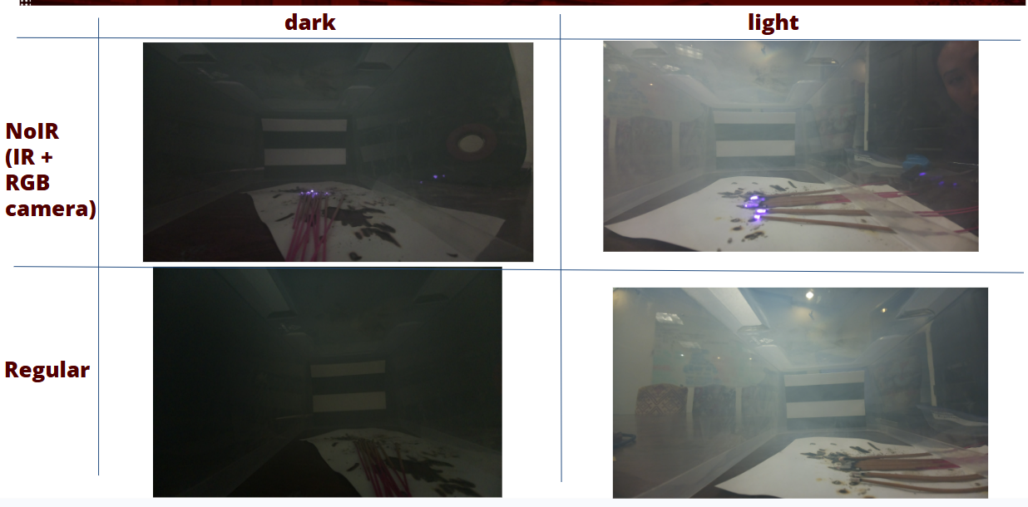

Preliminary Results
Smoke consistently degrades image quality across all three metrics.
- Low-light conditions: The NoIR camera significantly outperforms the Regular camera. The Regular camera detects almost no edges at any smoke level, while the NoIR camera continues to detect edges throughout.
- Normal lighting: Both cameras perform similarly at lower smoke levels, with performance degrading as smoke density increases.
These results demonstrate that the NoIR camera is better suited for deployment in smoky, low-light environments, ensuring reliable feature detection for downstream vision tasks.
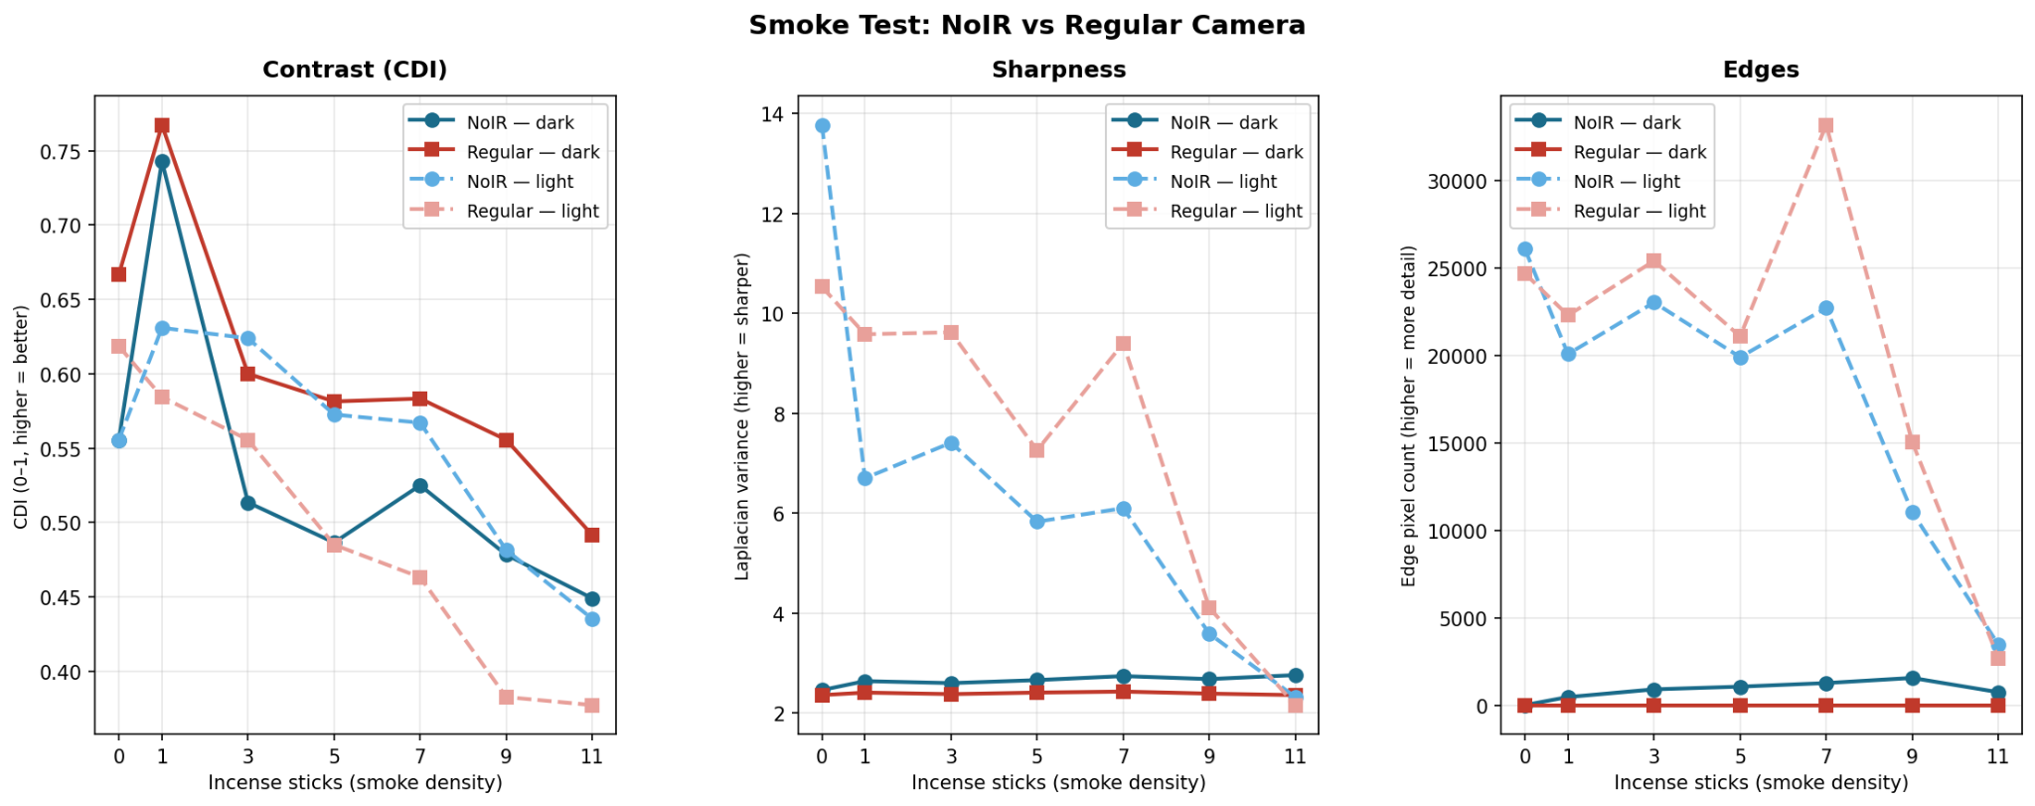

References
Here you acknowledge all the documents that you used as references throughout the text. Please use the IEEE reference format
https://ieeeauthorcenter.ieee.org/wp-content/uploads/IEEE-Reference-Guide.pdf

